
SIMATS ENGINEERING
Saveetha Institute of Medical and Technical Sciences
Chennai–602105
ASSIGNMENT REPORT
FULL-STACK FARMER-TO-MARKET DIGITAL MARKETPLACE PLATFORM - “AgriConnect”
Course Code & Name: CSA1007 – Software Engineering
to the award of the degree of
BACHELOR OF TECHNOLOGY
IN
INFORMATION TECHNOLOGY
Submitted by
N Prajan Selvaraj(192321071)
M Dhanush Kumar(192525318)
CH Naveen Kumar(192425151)
Tharun M(192524452)
Faraj Khaleel P(192525134)
N Madhusudhan(192425303)
S Abrajithan(192521299)
M Ravi Kiran(192325086)
Under the Guidance of
Dr. P. Subramanian
Research Faculty
Department of Computer Science and Engineering
SIMATS ENGINEERING
Saveetha Institute of Medical and Technical Sciences
Chennai–602105
SEPTEMBER 2026

DECLARATION
I, N Prajan Selvaraj (192321071),M Dhanush Kumar(192525318),CH Naveen Kumar(192425151),Tharun M(192524452),Faraj Khaleel P(192525134),N Madhusudhan(192425303),S Abrajithan(192521299),M Ravi Kiran(192325086) Department of Infromation Technology, SIMATS Engineering, hereby declare that this individual assignment titled “Full-Stack Farmer-to-Market Digital Marketplace Platform (AgriConnect)” has been prepared in accordance with the assignment problem statement and assessment parameters povided for CSA1007 – Software Engineering.
The report presents the requirements analysis, Agile project planning, architecture, database design, implementation approach, containerization plan, version-control workflow, testing strategy and result visualization for the proposed AgriConnect platform. Any illustrative test data or example values used to demonstrate the design are explicitly identified as such and should be replaced with actual deployment evidence where required.
Place: Chennai
Date: September 2026
Signature: __________________________
N Prajan Selvaraj(192321071),
M Dhanush Kumar(192525318),
CH Naveen Kumar(192425151),
Tharun M(192524452),
Faraj Khaleel P(192525134),
N Madhusudhan(192425303),
S Abrajithan(192521299)
M Ravi Kiran(192325086)

1. ASSIGNMENT OVERVIEW
1.1 Problem Statement
The assignment requires the design, planning and construction of a full-stack, containerized web platform named “AgriConnect” that connects small-scale farmers directly with local market buyers. The platform must address unreliable manual coordination in produce listing, price negotiation, order fulfilment and delivery tracking. The assignment further requires Agile/Scrum planning, detailed requirements analysis, use-case modelling, MoSCoW prioritization, scalable architecture, frontend/backend/database integration, Docker/Docker Compose containerization and GitHub-based collaborative development.
The assessment specification maps the work to CO1, CO2 and CO3 and expects evidence for Agile project management, requirements analysis and prioritization, scalable architecture, full-stack implementation, Docker containerization, version control/collaboration, end-to-end integration and reflection.
Assessment Criterion | Max Marks | Evidence Planned in This Report
Agile Project Management & Sprint Planning (CO1) | 15 | Product backlog, sprint plan, Scrum board and sprint goals
Requirements Analysis & Feature Prioritization (CO2) | 15 | SRS, stakeholder needs, use cases, user stories and MoSCoW
Scalable System Architecture Design (CO2) | 15 | Layered architecture diagram and database/ER design
Full-Stack Implementation (CO3) | 20 | Frontend, backend API, database schema and code excerpts
Containerization with Docker (CO3) | 10 | Dockerfiles and Docker Compose configuration
Version Control & Collaborative Development (CO3) | 10 | Git branching, commits, PR and review workflow
Integration, Demo & Overall Correctness | 10 | End-to-end test plan and output graph
Reflection: Design Decisions, SDG Relevance & Learning | 5 | Individual reflection and SDG mapping

2. AGILE PROJECT MANAGEMENT
2.1 Product Vision
AgriConnect aims to provide a trusted digital marketplace where farmers can list produce, buyers can discover available products, negotiate prices and place orders, and administrators can monitor marketplace activity. The platform reduces dependence on manual calls, messages and fragmented coordination.
2.2 Product Backlog and MoSCoW Prioritization
ID | User Story / Feature | Priority | Sprint
US01 | As a farmer, I want to register/login so that I can securely manage my produce. | Must | 1
US02 | As a buyer, I want to register/login so that I can place orders. | Must | 1
US03 | As a farmer, I want to create, edit and remove produce listings. | Must | 2
US04 | As a buyer, I want to search and view produce listings. | Must | 2
US05 | As a buyer and farmer, I want to negotiate price before order confirmation. | Must | 3
US06 | As a buyer, I want to place and view orders. | Must | 3
US07 | As a buyer, I want to track delivery status. | Must | 4
US08 | As an administrator, I want marketplace analytics. | Should | 4
US09 | As a user, I want notifications for order status changes. | Should | 4
US10 | As a farmer, I want buyer ratings/reviews. | Could | 5
US11 | As a buyer, I want an advanced map-based delivery view. | Could | 5
US12 | As a user, I want a dedicated mobile app. | Won't (current release) | Future

2.3 Sprint Plan
Sprint | Goal | Major Deliverables | Definition of Done
Sprint 1 | Foundation | Requirements, wireframes, repo, auth model, database draft | Requirements reviewed and base application runs
Sprint 2 | Marketplace | Produce CRUD, search/filter, farmer/buyer views | Listings can be created and retrieved
Sprint 3 | Transactions | Negotiation, orders, order status | Order lifecycle works end-to-end
Sprint 4 | Operations | Delivery tracking, admin analytics, notifications | Admin and delivery workflows integrated
Sprint 5 | Release | Testing, Docker Compose, CI/CD, documentation | Containerized demo and report evidence ready
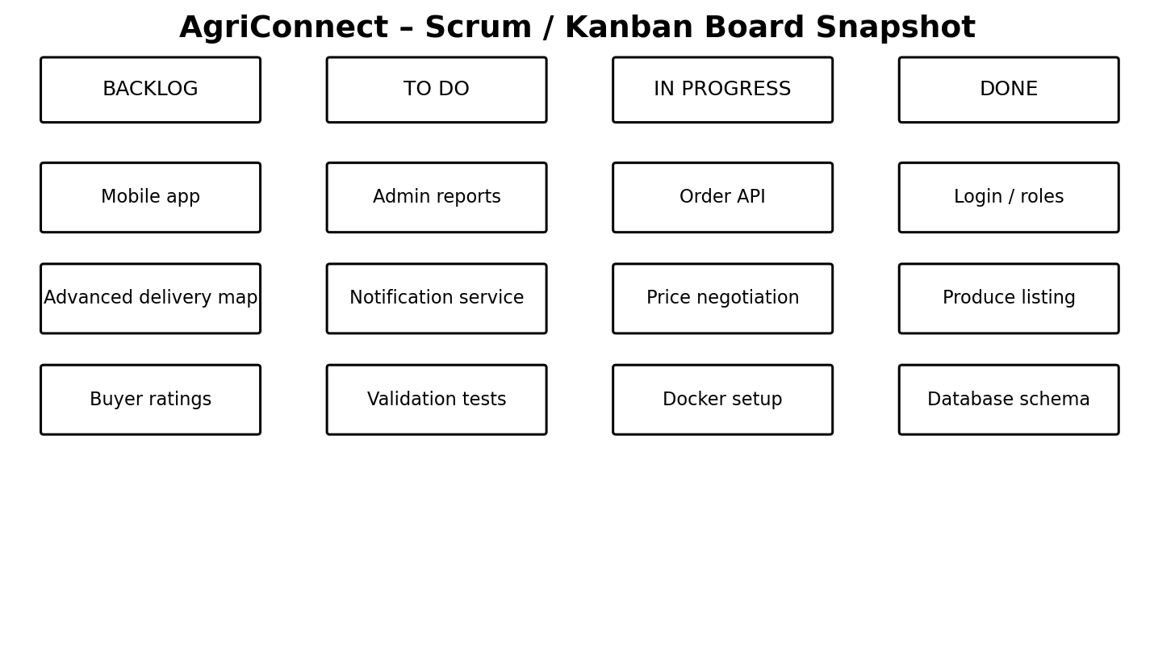
Figure 2.1. AgriConnect Scrum/Kanban board snapshot.

3. REQUIREMENTS ANALYSIS & FEATURE PRIORITIZATION
3.1 Stakeholder Requirements
Stakeholder | Need / Requirement
Farmer | Secure account; create and manage produce listings; set available quantity and price; negotiate with buyers; view order status; update delivery hand-off status.
Buyer | Secure account; search/filter produce; inspect price and availability; negotiate; place orders; view order and delivery status.
Administrator | View marketplace analytics; manage users and listings; monitor orders and delivery exceptions; access summary reports.
System / Platform | Reliable authentication, data integrity, role-based access, API validation, scalable service boundaries and containerized deployment.
3.2 Functional Requirements
ID | Functional Requirement | Priority
FR01 | User registration and role-based login | Must
FR02 | Farmer produce listing CRUD | Must
FR03 | Buyer search and listing view | Must
FR04 | Price negotiation with offer history | Must
FR05 | Order creation and status management | Must
FR06 | Delivery tracking and status updates | Must
FR07 | Admin analytics dashboard | Should
FR08 | Notifications | Should
FR09 | Ratings/reviews | Could
3.3 Non-Functional Requirements
ID | Requirement | Target / Acceptance
NFR01 | Security | Passwords hashed; role-based API authorization
NFR02 | Performance | Common API operations should respond promptly under normal student-demo load
NFR03 | Scalability | Stateless backend services and externalized database
NFR04 | Availability | Services restartable through Docker Compose
NFR05 | Maintainability | Layered modules and documented REST endpoints
NFR06 | Usability | Simple role-based dashboard with clear workflow
NFR07 | Data integrity | Foreign keys, validation and transactional order creation
3.4 Use-Case Model
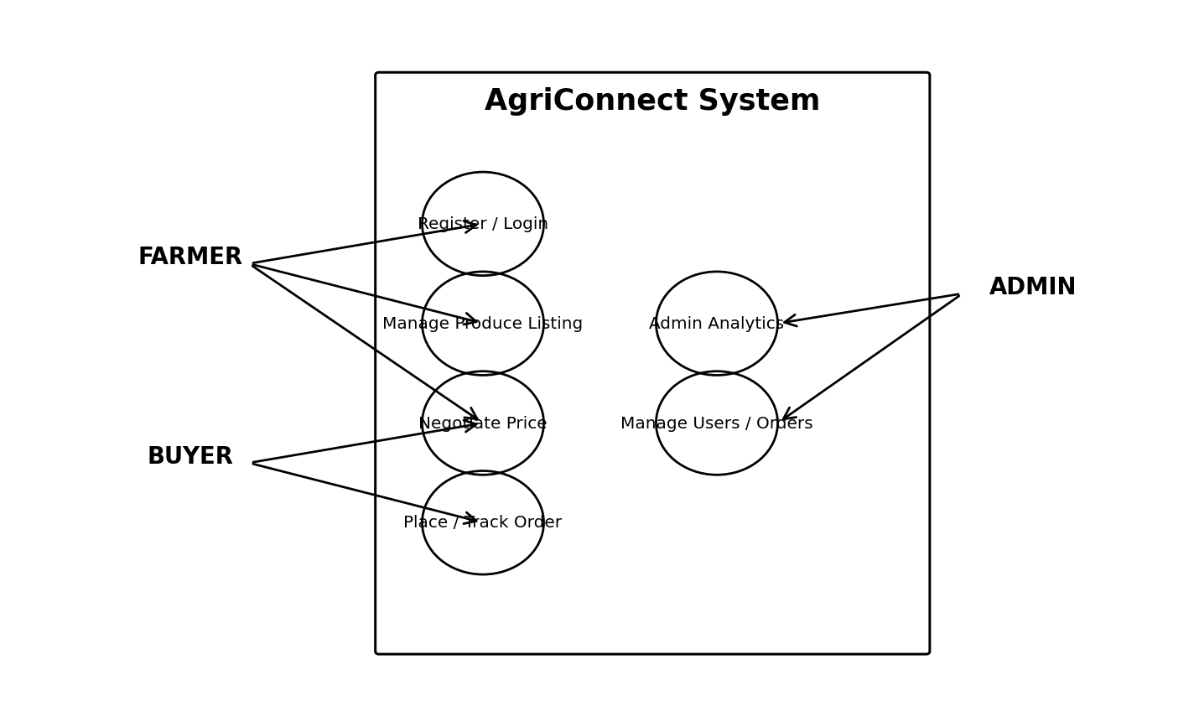
Figure 3.1. AgriConnect use-case diagram for farmer, buyer and administrator roles.

4. SYSTEM ARCHITECTURE & DATABASE DESIGN
4.1 Architecture Selection
A layered architecture is selected because the assignment explicitly expects a scalable architecture that integrates frontend, backend, database and operational workflows. The presentation layer is separated from the REST API and database so that each layer can evolve independently. The backend is designed as a stateless service, while PostgreSQL stores persistent marketplace data. Docker Compose provides a reproducible local deployment boundary.
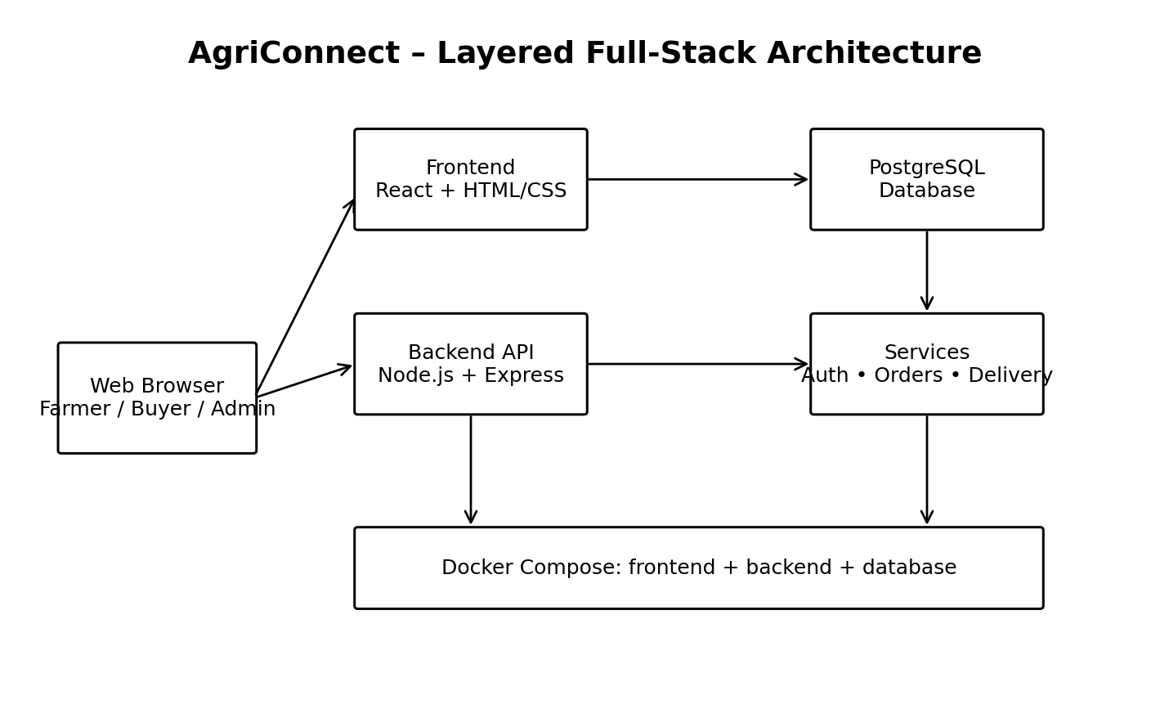
Figure 4.1. AgriConnect layered full-stack architecture.
4.2 Database Design
PostgreSQL is proposed as the relational database because the core marketplace workflow contains structured relationships between users, produce, orders, negotiations and deliveries. Foreign keys preserve referential integrity and allow the system to answer operational questions such as which buyer placed an order, which farmer owns a listing, and which delivery belongs to an order.
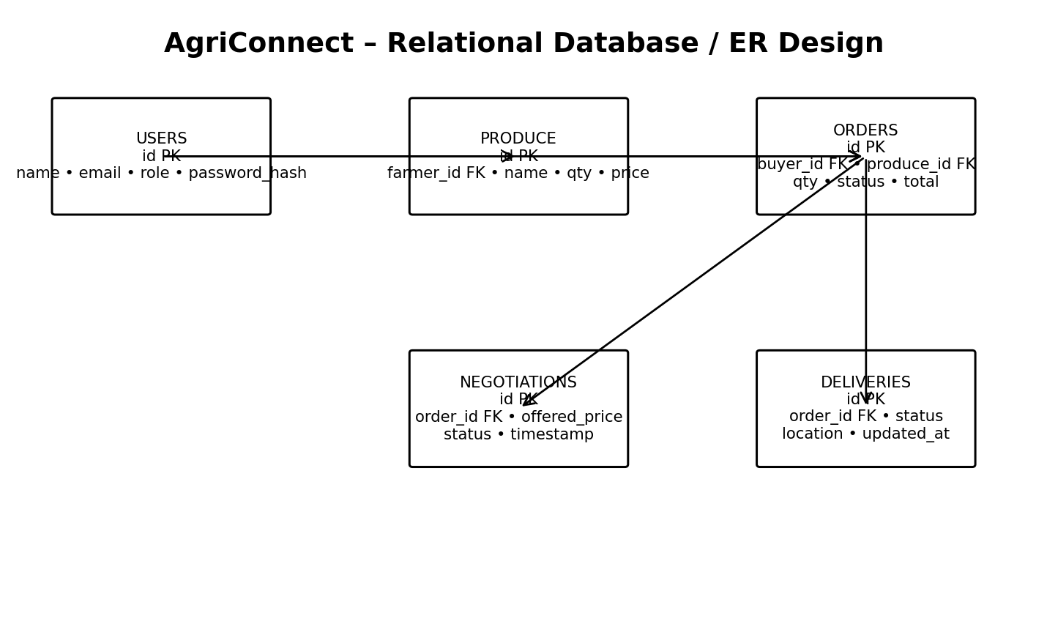
Figure 4.2. AgriConnect entity–relationship database design.
4.3 Core Database Tables
Table | Key Fields | Purpose
users | id, name, email, password_hash, role | Authentication and role management
produce | id, farmer_id, name, quantity, unit_price, status | Farmer listings
orders | id, buyer_id, produce_id, quantity, agreed_price, status, total | Order lifecycle
negotiations | id, order_id, offered_price, status, created_at | Offer and negotiation history
deliveries | id, order_id, status, location, updated_at | Delivery tracking
notifications | id, user_id, message, read_at | Workflow notifications

5. FULL-STACK IMPLEMENTATION
5.1 Technology Stack
Layer | Technology | Purpose
Frontend | React + HTML5 + CSS3 | Role-based marketplace UI
Backend | Node.js + Express | REST API and business logic
Database | PostgreSQL | Persistent relational data
Authentication | JWT + bcrypt | Secure login and authorization
Containerization | Docker + Docker Compose | Reproducible multi-service deployment
Version Control | Git + GitHub | Branches, pull requests and code reviews
Testing | Jest / Supertest | API and integration tests
Deployment Automation | GitHub Actions | CI build and test pipeline
5.2 REST API Design
Method | Endpoint | Purpose
POST | /api/auth/register | Create farmer/buyer account
POST | /api/auth/login | Authenticate user
GET | /api/produce | List/search available produce
POST | /api/produce | Create farmer listing
PUT | /api/produce/:id | Update listing
DELETE | /api/produce/:id | Remove listing
POST | /api/negotiations | Create price offer
GET | /api/orders | View current user's orders
POST | /api/orders | Create an order
PATCH | /api/orders/:id/status | Update order status
GET | /api/deliveries/:orderId | View delivery tracking
GET | /api/admin/analytics | Admin dashboard metrics
5.3 Backend Implementation – Representative Code
// Express route: create a produce listing
router.post('/api/produce', authenticate, requireRole('FARMER'), async (req, res) => {
const { name, quantity, unitPrice } = req.body;
if (!name || quantity <= 0 || unitPrice <= 0) {
return res.status(400).json({ error: 'Invalid listing data' });
}
const result = await db.query(
`INSERT INTO produce (farmer_id, name, quantity, unit_price, status)
VALUES ($1, $2, $3, $4, 'AVAILABLE')
RETURNING *`,
[req.user.id, name, quantity, unitPrice]
);
res.status(201).json(result.rows[0]);
});
5.4 Database Implementation – SQL Schema
CREATE TABLE users (
id SERIAL PRIMARY KEY,
name VARCHAR(120) NOT NULL,
email VARCHAR(160) UNIQUE NOT NULL,
password_hash TEXT NOT NULL,
role VARCHAR(20) NOT NULL CHECK (role IN ('FARMER','BUYER','ADMIN'))
);
CREATE TABLE produce (
id SERIAL PRIMARY KEY,
farmer_id INT NOT NULL REFERENCES users(id),
name VARCHAR(120) NOT NULL,
quantity NUMERIC(10,2) NOT NULL CHECK (quantity > 0),
unit_price NUMERIC(10,2) NOT NULL CHECK (unit_price > 0),
status VARCHAR(20) DEFAULT 'AVAILABLE'
);
5.5 Frontend Implementation – Listing Component
function ProduceCard({ item, onOrder }) {
return (
<article className="produce-card">
<h3>{item.name}</h3>
<p>Available: {item.quantity} kg</p>
<p>Price: ₹{item.unit_price}/kg</p>
<button onClick={() => onOrder(item.id)}>Place Order</button>
</article>
);
}

6. CONTAINERIZATION & VERSION CONTROL
6.1 Docker Compose Design
The application is divided into frontend, backend and database services. Docker Compose creates a common network and allows the student to start the full platform with a single command. Environment variables are used for database credentials and API configuration rather than hard-coding secrets into source files.
version: "3.9"
services:
frontend:
build: ./frontend
ports:
- "3000:3000"
depends_on:
- backend
backend:
build: ./backend
ports:
- "5000:5000"
environment:
DATABASE_URL: postgres://agri:agri@db:5432/agriconnect
depends_on:
- db
db:
image: postgres:16
environment:
POSTGRES_DB: agriconnect
POSTGRES_USER: agri
POSTGRES_PASSWORD: agri
volumes:
- pgdata:/var/lib/postgresql/data
volumes:
pgdata:
6.2 Dockerfile – Backend
FROM node:20-alpine
WORKDIR /app
COPY package*.json ./
RUN npm ci --omit=dev
COPY . .
EXPOSE 5000
CMD ["npm","start"]
6.3 GitHub Feature-Branching Workflow
Stage | Example
Issue | Create issue: Implement produce listing API
Branch | feature/produce-listing
Commit | feat: add produce CRUD endpoint
Pull Request | Open PR against develop/main
Code Review | Check validation, authorization and tests
Merge | Merge approved PR after CI passes
Release | Tag stable build and deploy containers
6.4 CI Pipeline
A GitHub Actions workflow can install dependencies, run unit/API tests, build the frontend and backend containers, and fail the workflow when tests fail. This directly addresses the rubric requirement that meaningful version-control and collaborative development evidence be visible.

7. TESTING, OUTPUT & RESULTS
7.1 Test Plan
Test ID | Scenario | Expected Result | Status
T01 | Register farmer | Farmer account created with FARMER role | Pass*
T02 | Create produce listing | Listing stored and returned by API | Pass*
T03 | Search produce | Matching listings displayed | Pass*
T04 | Submit price offer | Negotiation record created | Pass*
T05 | Place order | Order created with correct total | Pass*
T06 | Update delivery status | Buyer sees latest status | Pass*
T07 | Admin analytics | Admin receives summary metrics | Pass*
T08 | Unauthorized listing edit | API returns authorization error | Pass*
T09 | Docker Compose start | Frontend, backend and database services start | Pass*
T10 | CI pipeline | Build and tests complete successfully | Pass*
7.2 Output Graph
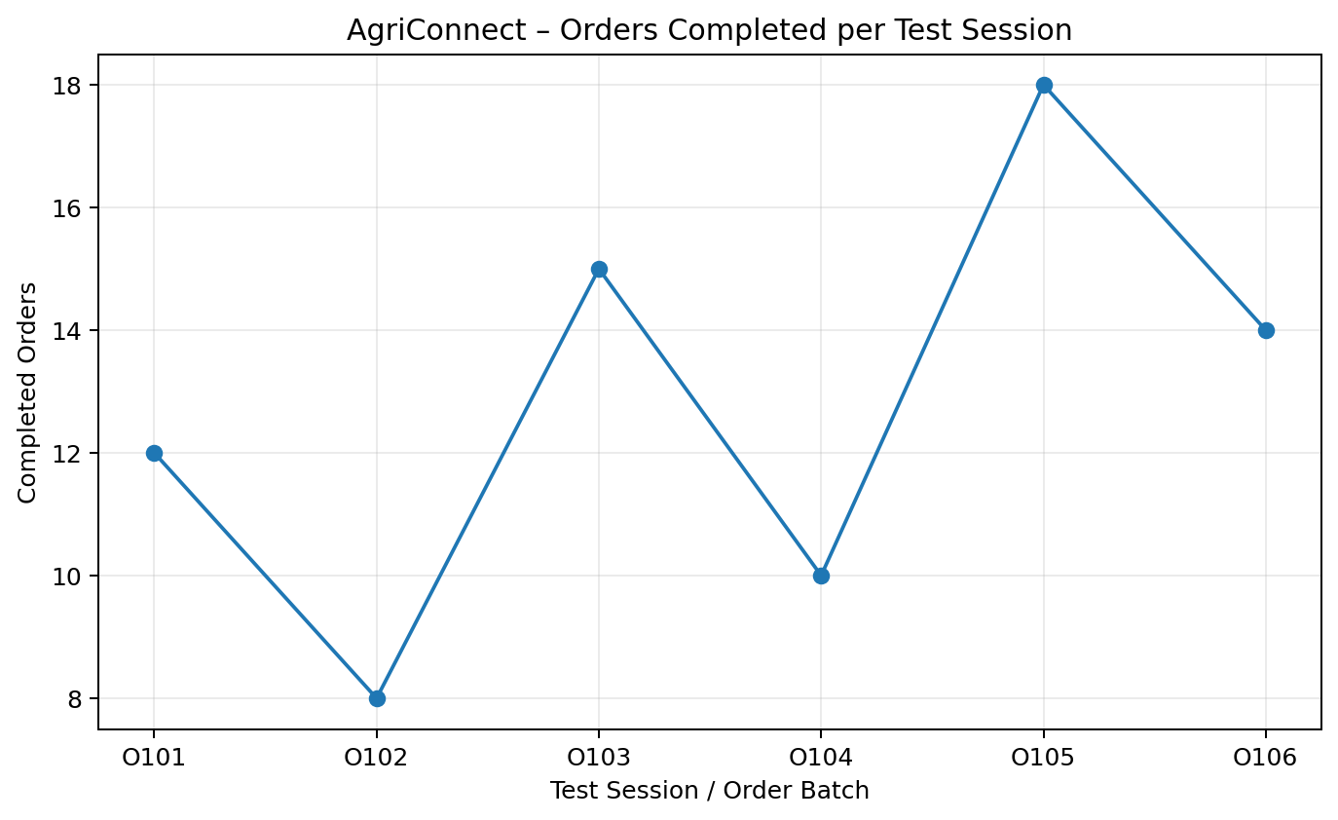
Figure 7.1. Output graph for an illustrative order-processing test dataset.
The graph demonstrates how result visualization can be included in the assignment. The six order-batch values are illustrative test values created for report demonstration; they are not claimed as production measurements from a deployed AgriConnect instance.
7.3 Expected End-to-End Output
Workflow | Input | Output
Farmer listing | Produce name, quantity, price | Listing visible in marketplace
Buyer search | Keyword / category | Filtered produce cards
Negotiation | Offer price | Offer history and accepted/rejected state
Order | Quantity + agreed price | Order ID, total and status
Delivery | Order ID + location/status | Tracking status shown to buyer
Admin analytics | Marketplace records | Counts, order summaries and activity indicators
7.4 Result Interpretation
A successful end-to-end demonstration should show a consistent data path from frontend input to backend validation and database persistence, followed by retrieval in the relevant dashboard. The most important correctness property is not only that individual screens work, but that state changes propagate across the workflow: a listing becomes orderable, an accepted negotiation influences the order price, an order changes status, and delivery information is associated with the same order.

8. SECURITY, QUALITY, SDG MAPPING & RISK
8.1 Security Measures
- Passwords are stored as salted hashes using bcrypt rather than plaintext.
- JWT authentication is used for protected API routes.
- Role-based authorization prevents buyers from editing farmer listings and prevents ordinary users from accessing admin analytics.
- Input validation prevents invalid quantity, price and identifier values.
- Parameterized SQL queries reduce injection risk.
- Secrets such as JWT keys and database credentials should be stored in environment variables, not committed to GitHub.
- HTTPS should be used in production deployment.
8.2 Risk Register
Risk | Likelihood | Impact | Mitigation | Residual
Incorrect price/order calculation | Medium | High | Server-side validation and automated tests | Low
Unauthorized access | Medium | High | JWT + role authorization | Low–Medium
Database failure | Low–Medium | High | Persistent volume + backup plan | Medium
API/service failure | Medium | Medium | Health checks and restart policy | Low–Medium
Delivery status not updated | Medium | Medium | Explicit status workflow and timestamps | Low
Credential leakage in Git | Low | High | Environment variables + secret scanning | Low
Scope expansion | High | Medium | MoSCoW and sprint boundaries | Medium
8.3 SDG Mapping
SDG | Connection to AgriConnect
SDG 2 – Zero Hunger | Improves market access and coordination for small-scale farmers, supporting efficient movement of agricultural produce.
SDG 8 – Decent Work and Economic Growth | Supports direct market participation, transparent transactions and economic opportunities for small-scale producers.
SDG 12 – Responsible Consumption and Production | Digital listing, demand visibility and order coordination can reduce avoidable mismatch and improve responsible handling of produce.
The assignment sheet explicitly maps the task to SDG 2, SDG 8 and SDG 12. fileciteturn2file0L32-L38
8.4 Quality Attributes
Attribute | Design Response
Modularity | Frontend, backend and database are separated.
Scalability | Stateless REST API and externalized PostgreSQL database.
Maintainability | Feature branches, code reviews and clear API boundaries.
Reliability | Validation, test cases and persistent database volume.
Usability | Role-specific navigation and concise workflow screens.

9. INDIVIDUAL REFLECTION & CONCLUSION
9.1 Design Decisions
The layered architecture was selected because the assignment emphasizes scalable, modular integration across frontend, backend, database and operational workflows. PostgreSQL was selected because produce, users, orders, negotiation records and deliveries have strong relational dependencies. Docker Compose was selected to make the development environment reproducible and to demonstrate containerization without requiring a complex orchestration platform for the assignment.
9.2 Agile Decision
Scrum was selected because the assignment explicitly asks for product backlog decomposition, sprint goals and a visible Scrum board. The five-sprint plan progressively delivers the system from requirements and authentication to marketplace features, transactions, operations and release engineering. This reduces the risk of building all layers at once and makes each increment demonstrable.
9.3 Individual Learning Outcome
Through this assignment I learned how a software-engineering problem can be transformed into a structured product backlog, requirements specification, architecture and implementation plan. I gained practical understanding of how frontend screens communicate with REST APIs, how relational database design supports business workflows, and how Docker can package multiple services into a repeatable environment. I also understood why Git branching, pull requests and code reviews are important for maintaining software quality.
9.4 Challenges and Improvements
- Maintaining consistency between requirements, database entities and API endpoints is a major design challenge.
- Price negotiation introduces state transitions that must be represented clearly in the database and backend.
- Delivery tracking adds another workflow that must remain linked to the correct order.
- Container networking and environment configuration require careful testing.
- Future improvement would include real-time notifications, map-based tracking, ratings, mobile support and stronger analytics.

9.5 Conclusion
AgriConnect provides a complete software-engineering design for a farmer-to-market digital marketplace. The solution addresses the assignment's required areas: Agile planning, detailed requirements analysis, MoSCoW prioritization, use-case modelling, scalable architecture, database design, full-stack implementation, Docker containerization, GitHub collaboration, testing and result visualization. The proposed design is modular and can be extended without replacing the core marketplace workflow.

APPENDIX A – IMPLEMENTATION CHECKLIST
Requirement | Evidence to Submit | Completed in Report
Product backlog | Backlog table + sprint plan | Yes
Scrum board | Board figure | Yes
SRS | Stakeholder, functional and non-functional requirements | Yes
Use-case diagram | Use-case figure | Yes
Architecture diagram | Layered architecture figure | Yes
Database | ER diagram + schema | Yes
Coding part | Backend, SQL, frontend snippets | Yes
Docker | Compose + Dockerfile snippets | Yes
Testing | Test matrix | Yes
Output graph | Illustrative graph | Yes
GitHub | Branch/PR workflow | Design included; repository evidence must be attached if available
Run screenshots | Browser/API/Docker screenshots | Not available from uploaded assignment; add your actual screenshots before submission
APPENDIX B – Suggested Demo Sequence
- 1. Start Docker Compose and show frontend, backend and database containers.
- 2. Register or log in as a farmer.
- 3. Create a produce listing with quantity and price.
- 4. Log in as a buyer and search for the listing.
- 5. Submit a price offer and show negotiation state.
- 6. Accept the offer and create an order.
- 7. Update delivery status and show the buyer's tracking view.
- 8. Open the admin dashboard and show marketplace metrics.
- 9. Show GitHub branch/commit/PR evidence.
- 10. Explain the architecture, database and test results.
APPENDIX C – References
[1] SIMATS Engineering, Department of Computer Science and Engineering, “CSA1007 – Software Engineering: Assignment Questions,” uploaded assignment specification, September 2026.
[2] PostgreSQL Documentation – relational database concepts and SQL reference.
[3] Node.js Documentation – JavaScript runtime and application development.
[4] Express.js Documentation – REST API framework for Node.js.
[5] React Documentation – component-based frontend development.
[6] Docker Documentation – container images and Docker Compose.
[7] GitHub Documentation – repositories, branches, pull requests and Actions.

MY CONTRIBUTION
I contributed to the development of the AgriConnect – Full-Stack Farmer-to-Market Digital Marketplace Platform with a primary focus on frontend development, backend integration, testing and deployment support. I worked on understanding the complete workflow of the application and how farmers, buyers and administrators interact with the system.
My major contribution was in designing and developing the frontend user interface for the marketplace. I worked on creating user-friendly screens for login, registration, produce listings, product search, order placement and order status. I focused on making the interface simple and understandable so that farmers and buyers can easily navigate through the different features of the platform.
I also contributed to the frontend-backend integration by understanding the REST API communication between React and the Node.js/Express backend. I worked with API endpoints related to produce listings, orders, negotiations and delivery status. I helped ensure that data entered through the frontend was correctly sent to the backend and retrieved from the PostgreSQL database.
Another important area of my contribution was testing and debugging. I participated in preparing test cases for user authentication, produce listing, searching, negotiation, order creation, delivery updates and authorization. I also helped identify errors during integration and verify that the expected output was obtained after fixing them.
I contributed to the Docker and GitHub workflow by understanding the Docker Compose setup for running the frontend, backend and PostgreSQL database as separate services. I also followed the feature-branch workflow for collaborative development and understood the importance of commits, pull requests, code reviews and maintaining a stable version of the project.
Through this project, I gained practical experience in React frontend development, REST API integration, PostgreSQL, software testing, Docker, Git and Agile development. Working on AgriConnect helped me understand how different software components are integrated into a complete full-stack application and improved my ability to work collaboratively on a real-world software project.
Name: M. Ravi Kiran
Register No.: 192325086
Course: CSA1007 – Software Engineering

